Test Case: runTestMultipleTimes
Step 1 - Enter username and password and click to button Enter : Credentials Entered
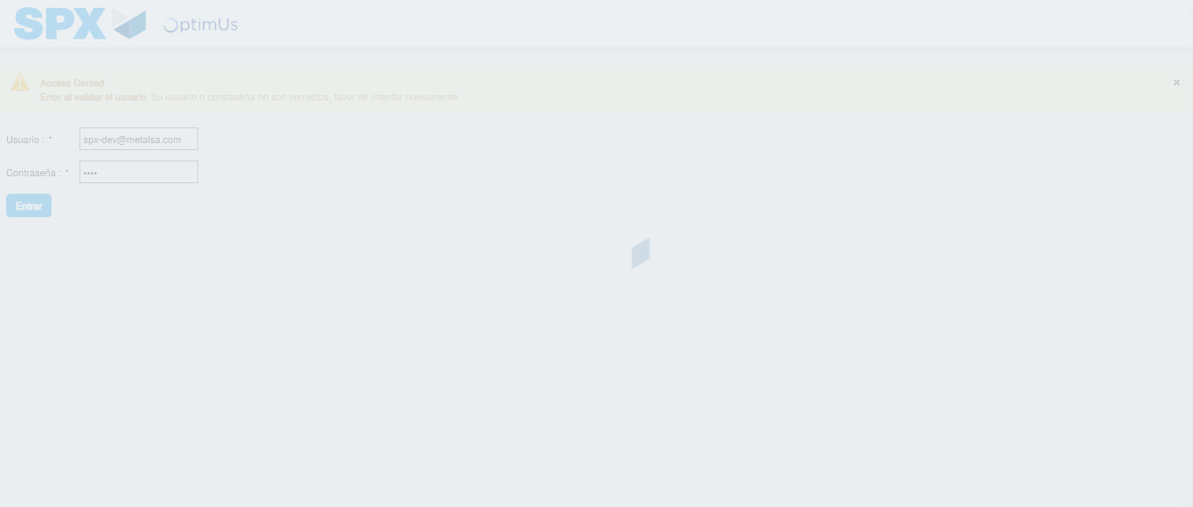Image file-name: QC_Testing-runTestMultipleTimes-nov. 20 2025, 02 19 25 p. m.

Step 2 - Select to UEN and Access to Administrador Roles Menu: UEN Correctly selected and Correct access
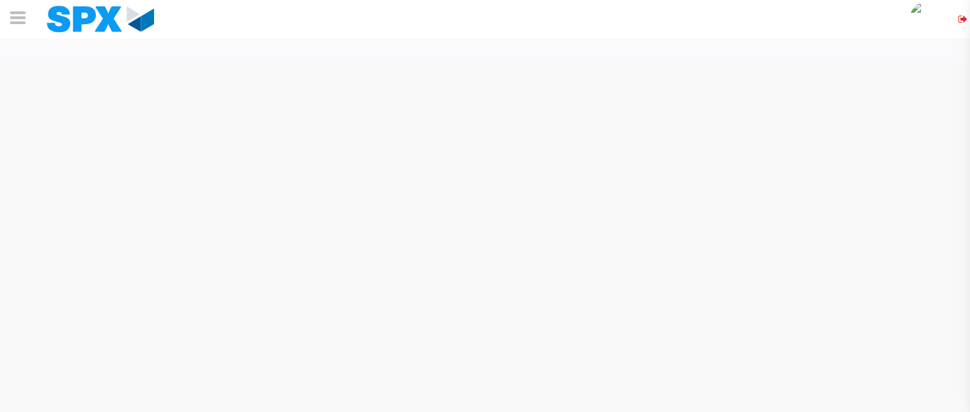Image file-name: QC_Testing-runTestMultipleTimes-nov. 20 2025, 02 19 28 p. m.

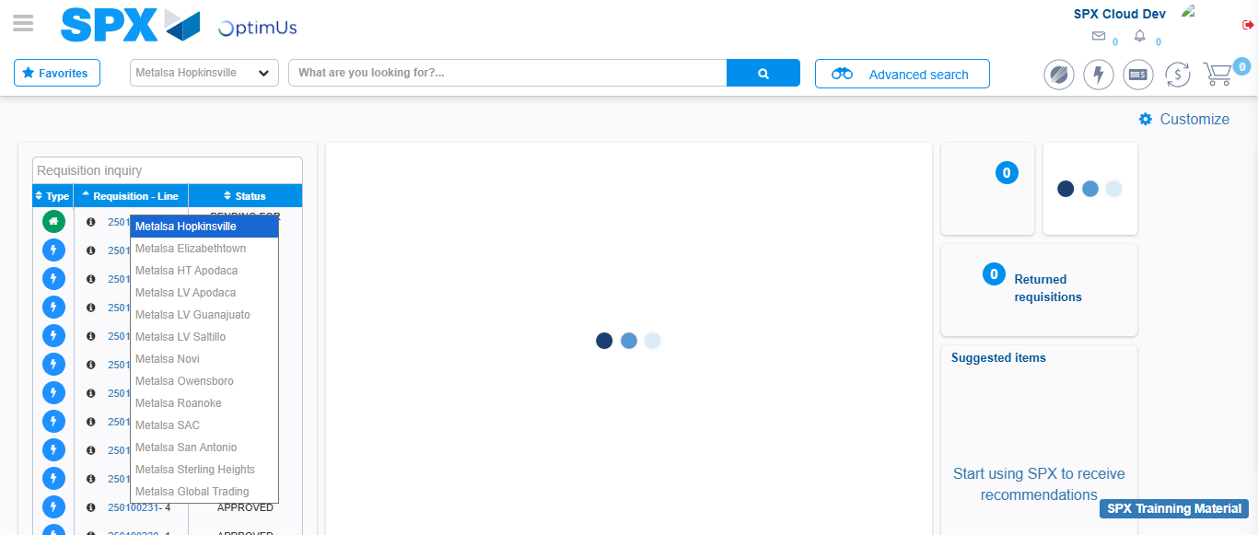Image file-name: QC_Testing-runTestMultipleTimes-nov. 20 2025, 02 19 34 p. m.

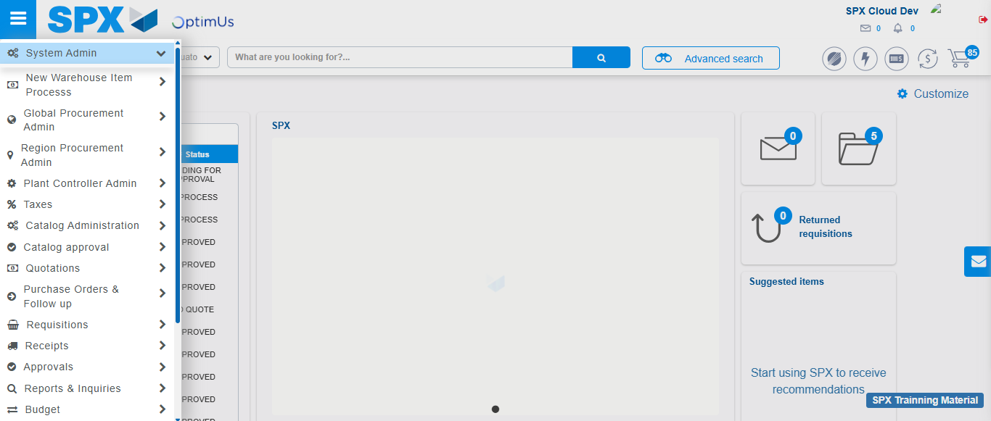Image file-name: QC_Testing-runTestMultipleTimes-nov. 20 2025, 02 19 35 p. m.

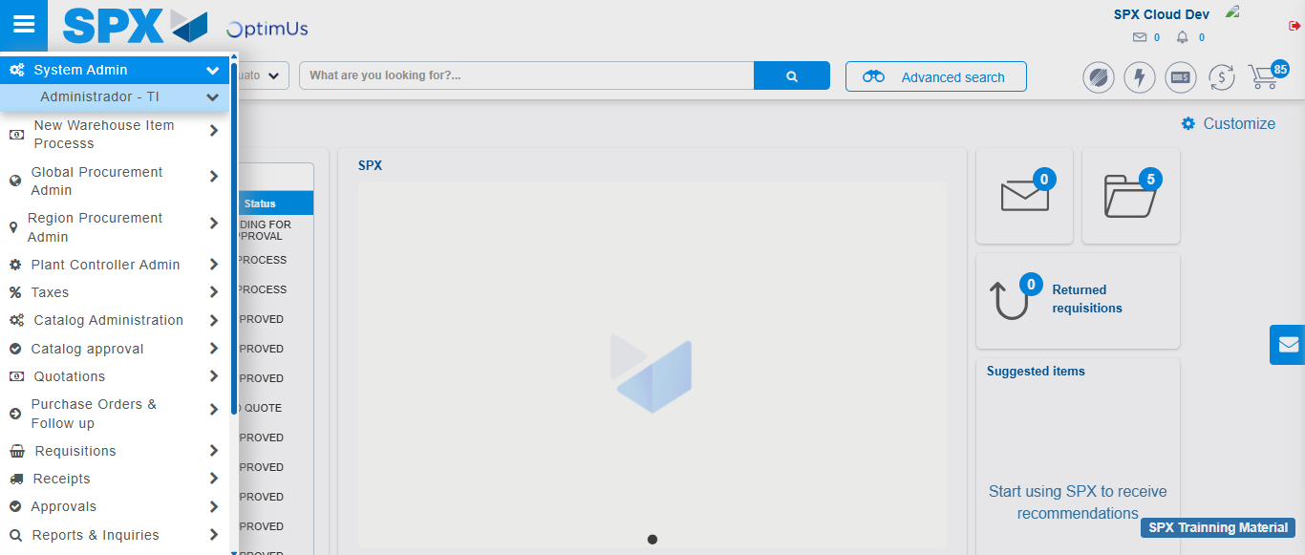Image file-name: QC_Testing-runTestMultipleTimes-nov. 20 2025, 02 19 36 p. m.

Image file-name: QC_Testing-runTestMultipleTimes-nov. 20 2025, 02 19 37 p. m.

Step 3 - Click to Buttons View Menu and Search Filter with Menu Name and Add new record and Delete Record: Correct Search and Record successfully added and Record successfully deleted
Image file-name: QC_Testing-runTestMultipleTimes-nov. 20 2025, 02 19 37 p. m.

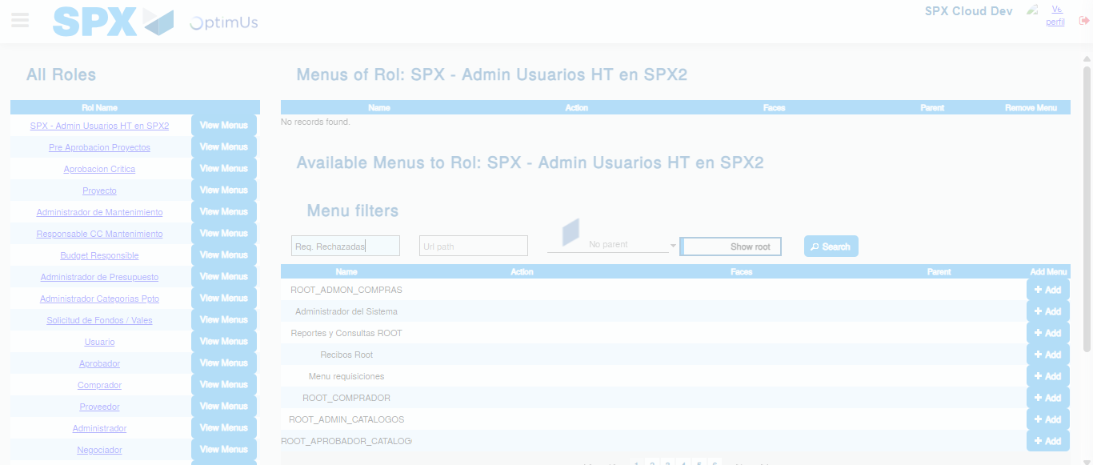Image file-name: QC_Testing-runTestMultipleTimes-nov. 20 2025, 02 19 38 p. m.

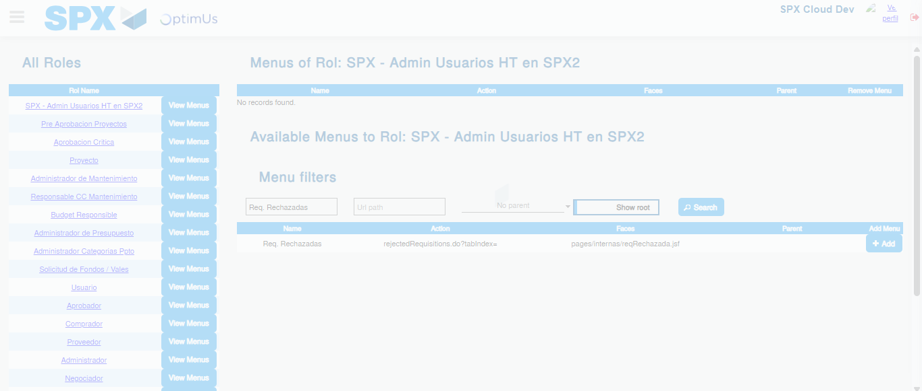Image file-name: QC_Testing-runTestMultipleTimes-nov. 20 2025, 02 19 39 p. m.

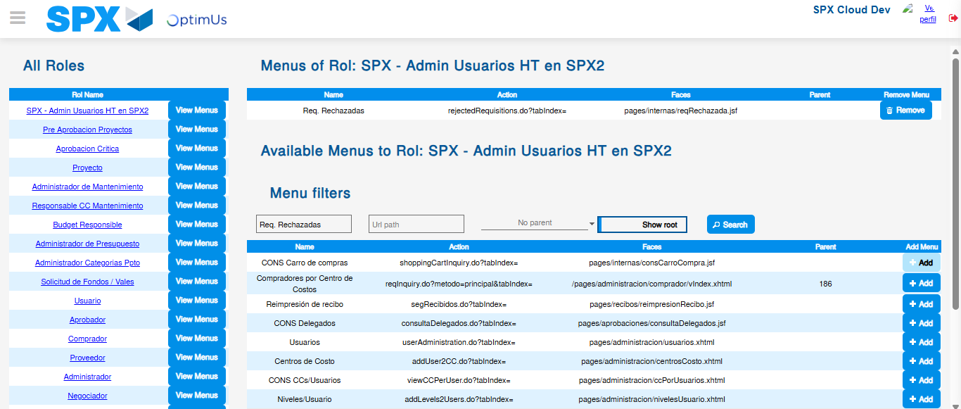Image file-name: QC_Testing-runTestMultipleTimes-nov. 20 2025, 02 19 42 p. m.

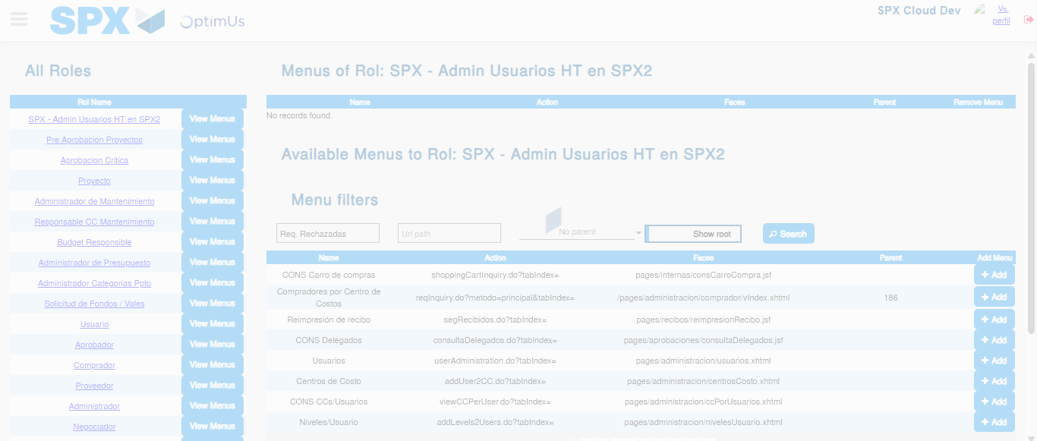Image file-name: QC_Testing-runTestMultipleTimes-nov. 20 2025, 02 19 43 p. m.

